**Northlake Senior Campus : Chemistry Year 11 2019**

**Topic Test: Chemical Bonding and Separating Mixtures**

**Name: ______________________ Total : 50 marks**

**Part 1: MULTIPLE CHOICE (15 marks)**

1. Liquid mercury solidifies at a temperature of –39oC. Which one of the following statements is not correct?

Liquid mercury:

a) is malleable

b) expands when heated

c) is denser than water

d) is a poor conductor of electricity

2. Which of the following lists species that contain only covalent bonds?

A Na2CO3(s), SO2(g), P4(s)

B CO32–(aq), SO42–(aq), HCl(g)

C Al(s), SnSO4(s), N2O4(g)

D Mg(s), HCl(g), NH4NO3(s)

3. Which of the following electron dot formulas is incorrect?

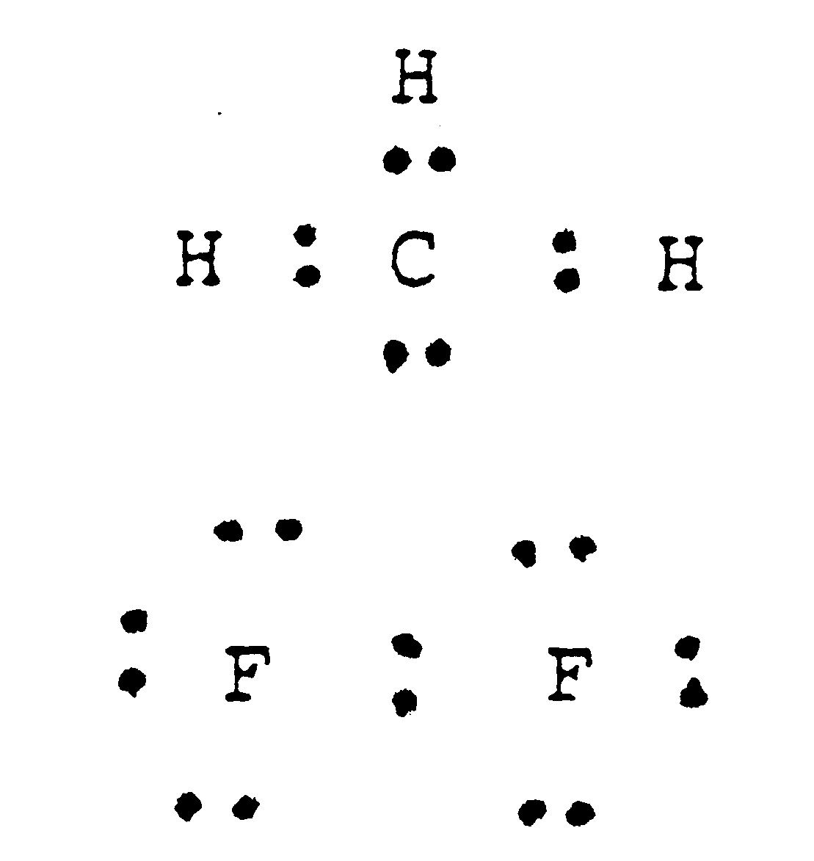



a) c)

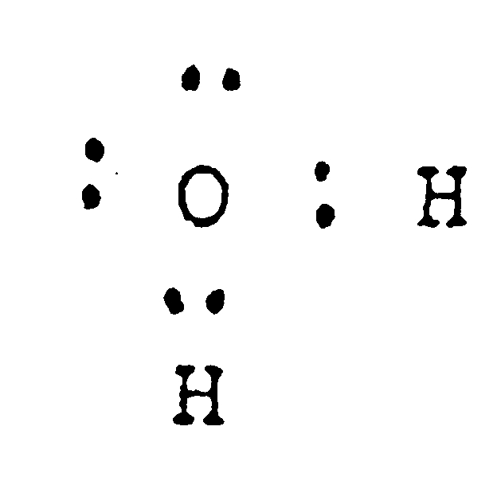

1. d)

4. The number of lone pairs in a molecule of chlorine is

a) 3

b) 6

c) 4

d) 7

5. The number of bonding electron pairs in a molecule of nitrogen is

a) 1

b) 2

c) 3

d) 4

6. The formation of an ionic compound from a reaction between two elements involves:

1. sharing of pairs of electrons between atoms.
2. donation of valence electrons to the entire crystal lattice.
3. transfer of electrons between atoms.
4. ionization of the atoms of the more electronegative element.

7. Which of the following bond types are NOT electrostatic in nature?

1. ionic bonds
2. metallic bonds
3. covalent bonds
4. They are all electrostatic in nature

The next three items refer to the following information.

Three solid substances were tested in three ways:

|  |  |  |  |
| --- | --- | --- | --- |
|  | Test 1 | Test 2 | Test 3 |
|  | Hit a small lump of the substance with a hammer | Place substance in a crucible and heat gently | Test some of the substance for electrical conductivity |
| Result for  substance I | flattened | melted easily | non-conductor in both the solid and liquid state |
| Result for  substance II | shattered | no visible change | non-conductor in the solid state: conducted electricity in the liquid state |
| Result for  substance III | shattered | No visible change | non-conductor in both the solid and liquid state |

8. The most probable chemical structure for solid substance I is

1. metallic lattice
2. covalent molecular
3. covalent network lattice
4. ionic lattice

9. The most probable chemical structure for solid substance II is

1. metallic lattice
2. covalent molecular
3. covalent network lattice
4. ionic lattice

10. The most probable chemical structure for solid substance III is

* 1. metallic lattice

b) discrete (individual) molecules

c) covalent network lattice

d) ionic lattice

11. The physical properties of solid metals can best be explained by proposing that

* 1. each metal atom is bonded in the crystal lattice by covalent bonds.
  2. positive metal ions are arranged in an orderly way, with valence electrons able to move freely through the crystal lattice.
  3. positive and negative metal ions are arranged in an orderly way, with mobile valence electrons able to migrate easily around the crystal lattice.
  4. each metal atom is surrounded by a variable number of valence electrons, which complete a “noble gas” electronic structure in the crystal lattice.

12. Phosphorous is in the group V of the periodic table. The bonding in a P2H4 molecule would be best represented by the electron dot formula

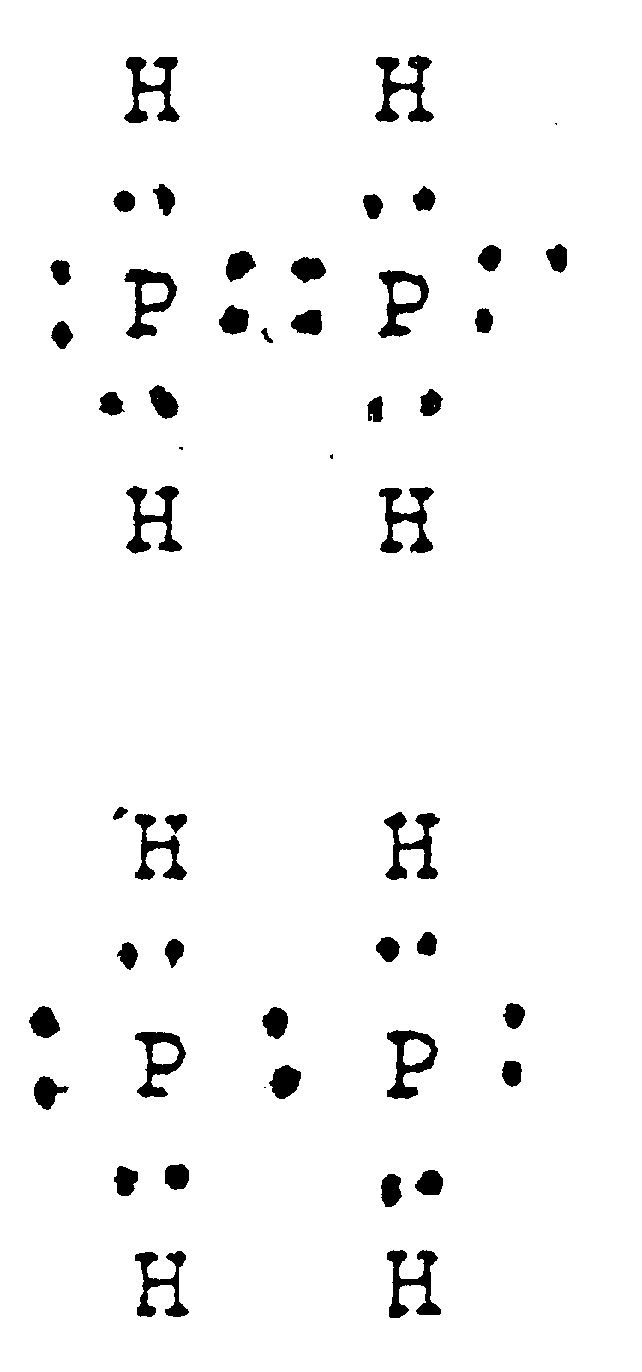

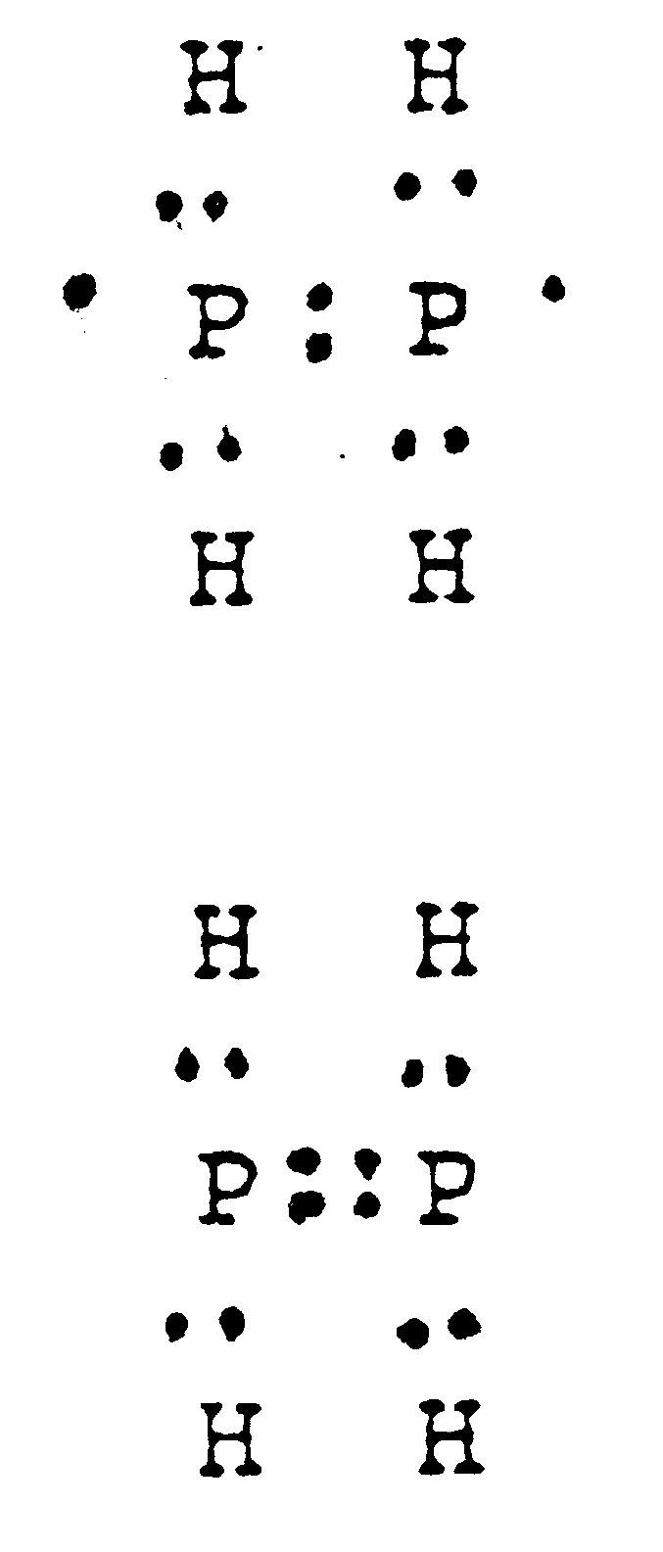

a) c)

b) d)

13. Copper wire may be bent easily without breaking.

The best explanation of this is that:

a) slight changes in relative positions of adjacent copper particles do not

break the metallic bonds as these are equally strong in all directions.

b) the forces between copper atoms are weak, allowing the copper particles

to be easily moved around.

1. copper particles are strongly bonded in layers but only weakly bonded

between layers.

1. copper particles are arranged in flat molecules which freely slide over

each other, allowing the material to be bent.

14. Which of the following mixtures could be separated by filtration?

1. Water and salt
2. Iron filings and sand
3. Water and sand
4. Water vapour and hydrogen gas

15. “Buckyballs” (or buckminsterfullerine) are recently discovered stable supermolecules containing only carbon atoms. Buckminsterfullerine and graphite are therefore:

* 1. allotropes
  2. isomers
  3. isotopes
  4. covalent network compounds

## End of Part 1Task 7**:** YEAR 11 CHEMISTRY TEST

## Chemical Bonding and Separation Techniques

## ANSWER BOOKLET

**NAME : DATE :**

### MULTIPLE CHOICE ANSWER SHEET (15 marks)

8. [A] [B] [C] [D]

9. [A] [B] [C] [D]

10. [A] [B] [C] [D]

11. [A] [B] [C] [D]

12. [A] [B] [C] [D]

13. [A] [B] [C] [D]

14. [A] [B] [C] [D]

15. [A] [B] [C] [D]

1. [A] [B] [C] [D]

2. [A] [B] [C] [D]

3. [A] [B] [C] [D]

4. [A] [B] [C] [D]

5. [A] [B] [C] [D]

6. [A] [B] [C] [D]

7. [A] [B] [C] [D]

**Part 2: WRITTEN SECTION (35 marks)**

Question 16

Write the corresponding name or formula for the substances listed below. **(5 marks)**

a Formula of sodium sulfate: ________________________________

b Formula of magnesium phosphate: _________________________________

c Formula for Calcium carbonate _______________________________

d Name of (NH4)Cl: _________________________________

e Name of Mn(NO3)2 _________________________________

**Question 17**

Draw electron dot diagrams (Lewis structure diagrams) for the substances listed below, showing all valence electrons. Electron pairs may be shown as : or –. **(8 marks)**

|  |  |
| --- | --- |
| *Molecule* | *Lewis Diagram* |
| HBr |  |
| CF4 |  |
| PH3 |  |
| [NH4]+ |  |

Question 18 (7 marks)

Explain the following properties of calcium chloride.

a Calcium chloride solid is brittle and breaks apart easily when struck with a hammer.

(3 marks)

b Solid calcium chloride crystals do not conduct electricity. (2 marks)

c Molten calcium chloride does conduct electricity. (2 marks)

1. Classify the following as physical or chemical changes: (2 marks)
   1. dissolving salt in water _____________________

* 1. burning paper _____________________
  2. melting candle wax ______________________
  3. tarnishing of silver ______________________

20. *“Metals are good conductors electricity.”*

Explain why this is so, in terms of bonding and structure. (3 marks)

()

21. Students are given a mixture of the following substances, construct a flowchart that details a process (with appropriate equipment) which could be used to separate all substances into pure forms:

*Nickel beads, water, marble chips, copper (II) sulphate* [Note: copper (II) sulphate is soluble in water] (6 marks)

22. Classify the following as ionic or covalent network, covalent molecular or metallic substances: (4 marks)

**N2, SO2, KF, ICl, Al2O3, NH4Cl, SiC, Na**

|  |  |  |  |
| --- | --- | --- | --- |
| **IONIC** | **COVALENT NETWORK** | **COVALENT MOLECULAR** | **METALLIC** |
|  |  |  |  |

